COPYMASTER |  |  | VERSION: 1.02
Project Name: Sorento_PTZ | Product Name: Acer Nitro V 16S AI | Product Type: essential AI gaming laptop
Writer: Clark Gurden | PMKT: Sylvia Pan
Updates
Added xbox game pass related agw/A+ disclaimers and ksps
Changed NV content
- Reflex 2-> reflex and messaging
AI tops and laptop gpu same line
Updated intel messaging
UNDER EMBARGO

AGW Meta Content
Page Title (60) | Acer Nitro V 16S AI | Copilot+ PC
Meta Description (160) | Slim metal design, up to an Intel® Core™ Ultra 7 processor 355, and NVIDIA® GeForce RTX™ 5070 Laptop GPU power this Copilot+ PC built for gaming on the go, study, and creation.
Product Card Description (120) | Slim, smart, and built for balance — AI-driven power meets style for gaming, learning, and life.

AGW Page Content
Product Name |  | Acer Nitro V 16S AI
Tagline (60)
Key Message/Page Intro
Key Message/Intro (220) |  | The Acer Nitro V 16S AI Copilot+ PC combines up to an Intel® Core™ Ultra 7 processor 355 with an NVIDIA® GeForce RTX™ 5070 Laptop GPU in a sleek metal build for gamers and students who value AI efficiency and portability.
Copilot+PC/Windows Message |  | Copilot+ PCs are the fastest, most intelligent and secure Windows PCs ever.  Next-level you. Now with AI.
Logo |  | 
CTA Button |  | Watch Video
CTA Button Link |  | https://youtu.be/aZSq94Ldluo
Logos / Badges / Awards
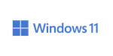 | 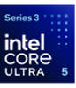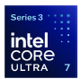 |  |  |  |  |  |  | 
Media Reviews – ENGLISH (ENG)
Publish to USA / CA
Section Headline |  | Media Reviews
Text Content
Image Selection |  | Generic | Generic |  | Generic |  | Generic
Reviewer Name
Quote (180)
Button & URL |  | Read More | Read More |  | Read More |  | Read More

Partner KSP 1
Image Ref |  | 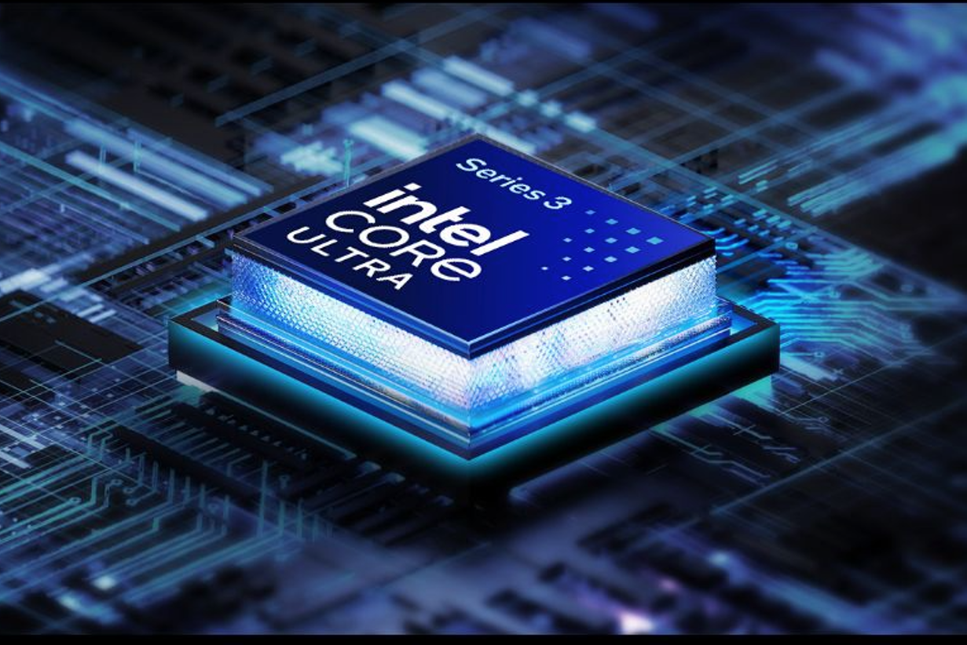
KSP Headline |  | Serious gaming. Zero bulk.
KSP Body |  | Games run faster and battery goes further with Intel® Core Ultra Series 3 processors, paired with a discrete GPU. Powered by next-gen Performance cores, creator-class media engines, and AI that sharpens your clips without touching your FPS, you get high-performance gaming in a sleek laptop that goes wherever you do.
Overline (20) |  |  |  | Up to Intel® |  | Up to
Spec (30) |  | Windows 11 Home |  | Core™ Ultra 7 |  | 8 Cores
Underline (20) |  | Operating System |  | processor 355 |  | 4P + 4LPE
Partner KSP 2
Tagline |  | Game Changer
Series Headline |  | GeForce RTX™ 50 Series Laptops
Tech Headline |  | Powered by NVIDIA Blackwell and AI
Overline (20) |  | Up to NVIDIA® |  |  | 5th Gen Tensor Cores
Spec (30) |  | GeForce RTX™ 5070 |  |  | Max AI Performance
Underline (20) |  | Laptop GPU (798 AI TOPS) |  |  | with FP4 & DLSS 4
Partner KSP 2.1
Image reference |  | 
Tech Headline |  | DLSS 4
KSP Headline |  | Supreme Speed. Superior Visuals. Powered by AI.
KSP Body |  | DLSS is a revolutionary suite of neural rendering technologies that uses AI to boost FPS, reduce latency, and improve image quality. ‌The latest breakthrough, DLSS 4, brings new Multi Frame Generation and enhanced Ray Reconstruction and Super Resolution, powered by GeForce RTX™ 50 Series GPUs and fifth-generation Tensor Cores. DLSS on GeForce RTX is the best way to play, backed by an NVIDIA AI supercomputer in the cloud constantly improving your PC’s gaming capabilities.
Partner KSP 2.2
Image reference |  | 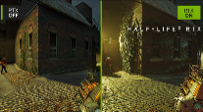
Tech Headline |  | Full Ray Tracing with Neural Rendering
KSP Headline |  | Game-Changing Realism
KSP Body |  | The NVIDIA Blackwell architecture unlocks the game-changing realism of full ray tracing. Experience cinematic quality visuals at unprecedented speed powered by GeForce RTX 50 Series with fourth-gen RT Cores and breakthrough neural rendering technologies accelerated with fifth-gen Tensor Cores.
Partner KSP 2.3
Image reference |  | 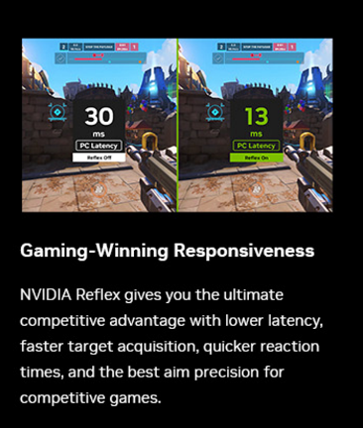
Tech Headline |  | NVIDIA Reflex
KSP Headline |  | Game-Winning Responsiveness
KSP Body |  | NVIDIA Reflex gives you the ultimate competitive advantage with lower latency, faster target acquisition, quicker reaction times, and the best aim precision for competitive games.
Partner KSP 2.4
Image reference |  | 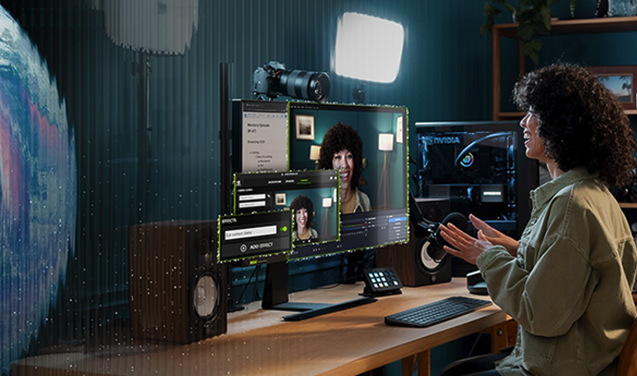
Tech Headline |  | RTX AI PC
KSP Headline |  | NVIDIA Powers the World’s AI. And Yours.
KSP Body |  | Upgrade to advanced AI with NVIDIA GeForce RTX™ GPUs and accelerate your gaming, creating, productivity, and development. Thanks to built-in AI processors, you get world-leading AI technology powering your Windows PC.
Partner KSP 2.5
Image reference |  | 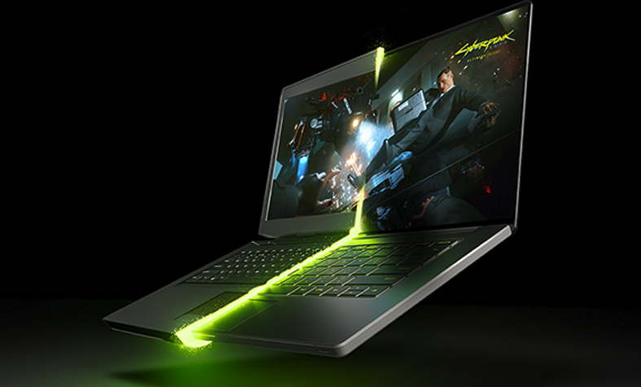
Tech Headline |  | NVIDIA Blackwell Max-Q
KSP Headline |  | Optimized Power and Performance
KSP Body |  | Max-Q is designed from the ground up for maximum efficiency, delivering a massive leap in performance and battery life.
KSP 1
KSP Headline (40) |  | Sleek Form, Solid Build
KSP Body (220) |  | A refined metal chassis and ~17.9 mm thin profile make this Copilot+ PC light yet durable — finished with a 4-zone RGB keyboard that adds a splash of attitude to your workspace or game setup.
KSP 2
Image reference |  | 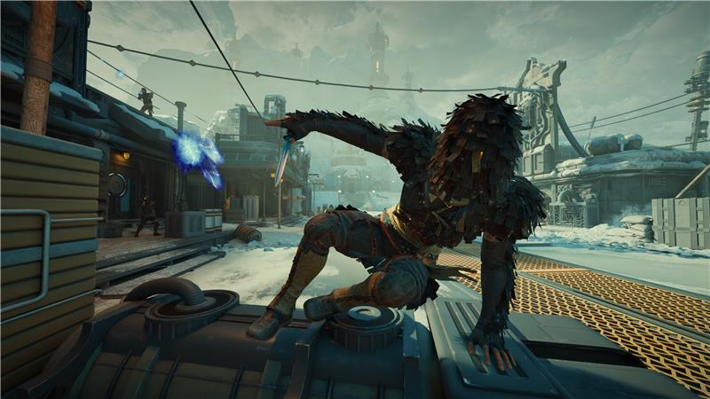
KSP Headline (40) |  | Precision in Every Pixel
KSP Body (220) |  | The 16-inch WUXGA (1920 × 1200) display offers up to 180 Hz refresh and 100% sRGB color — bringing sharp motion and balanced color for games, streams, and creative projects.
Overline (20) |  | Up to 16-inch | Up to |  | Up to
Spec (30) |  | WUXGA | 180Hz |  | 100% sRGB |  | MUX Switch
Underline (20) |  | 1920 x 1200 Display | Refresh Rate |  | Color Gamut |  | Equipped
KSP 3
KSP Headline (40) |  | Cool Control for Every Move
KSP Body (220) |  | Dual-fan, dual-intake, dual-exhaust cooling keeps temperatures in check so your Intel® and NVIDIA® hardware perform at their best through long sessions of gaming or studying.
KSP 4
Image reference |  | 
Logos (to be placed in main ksp graphic) |  | or   (choose one))
KSP Headline (40) |  | Full Speed, No Lag
KSP Body (220) |  | Connect with Thunderbolt™ 4, Killer™ Wi-Fi 6E, and Ethernet E2600 for stable low-latency performance during competitive play, online classes, and streaming.
KSP 5
Image reference |  | 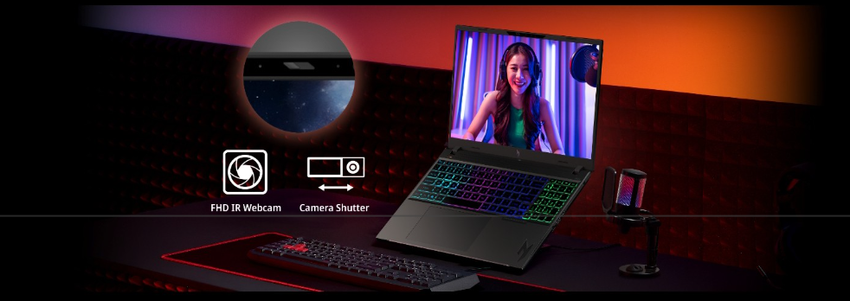
KSP Headline (40) |  | Sharper Focus, Total Privacy
KSP Body (220) |  | The FHD IR camera keeps you clear and defined in every stream or team chat, while the camera shutter adds instant privacy when the match is over. Stay connected when it counts, unseen when it doesn’t.
KSP 6
KSP Headline (40) |  | Smart Control, One Touch
KSP Body (220) |  | Access NitroSense and Acer My Key for instant tuning and shortcuts with their designated keys. Manage cooling, lighting, and favorite apps without breaking your flow.
KSP 6.1
KSP Headline (40) |  | NitroSense
KSP Body (180) |  | Real-time control over fan speed and system performance for stable, optimized gameplay.
KSP 6.2
KSP Headline (40) |  | Acer My Key
KSP Body (180) |  | Customize quick-access shortcuts to open tools or apps instantly, saving time and clicks.
KSP 7
KSP Headline (40) |  | Acer Intelligence Space
KSP Body (220) |  | Launch smarter performance through Acer Intelligence Space, your hub for AI-ready tools and hardware insights that fuel productivity, creativity, and gaming
KSP 8 (CURRENT)
KSP Headline (40) |  | Discover Your Next Favorite Game
KSP Body (220) |  | Play hundreds of PC games with your new Acer Nitro Windows 11 PC and three months of PC Game Pass, including EA Play. With new games added all the time, there’s always something new to play.
GO LIVE 3/1/26
NEW MS PARTNER KSP 8 (US)
KSP Headline |  | Play 200+ Games for One Low Monthly Price.
KSP Body |  | Play Forza Horizon 5, State of Decay 2, and 200+ more games on your new Acer Nitro Windows 11 PC with 2 months of Xbox Game Pass Premium. New Xbox published games join the library within 1 year of launch. Dive into a range of legendary franchises from Call of Duty to Minecraft and everything in between. Get in-game benefits for the biggest games like League of Legends, Call of Duty: Warzone, and Rainbow Six Siege, and more. Play and earn up to $50 a year in the Store with Rewards. Find your community with Xbox and play anywhere you want
NEW MS PARTNER KSP 8 (WW)
KSP Headline |  | Play 200+ Games for One Low Monthly Price.
KSP Body |  | Play Forza Horizon 5, Halo Infinite, and 200+ more games on your new Acer Nitro Windows 11 PC with 2 months of Xbox Game Pass Premium. New Xbox published games join the library within 1 year of launch. Explore a range of global franchises from Minecraft to Halo and everything in between. Get in-game benefits for the biggest games like League of Legends, Call of Duty: Warzone, and Rainbow Six Siege, and more. Play and earn up to 50,000 points per year with Rewards. Find your community with Xbox and play anywhere you want.
Disclaimers
 | This product is not designed for cryptocurrency mining uses. Damages to your product arising from cryptocurrency mining or related activities are excluded from your product’s warranty.
 | The terms HDMI and HDMI High-Definition Multimedia Interface and the HDMI Logo are trademarks or registered trademarks of HDMI Licensing Administrator, Inc. in the United States and other countries.
 | Specifications may vary depending on model and/or region. All models subject to availability.
Intel® technologies’ features and benefits depend on system configuration and may require enabled hardware, software, or service activation. Performance varies depending on system configuration. No product or component can be absolutely secure.

© Intel Corporation. Intel, the Intel logo, and other Intel marks are trademarks of Intel Corporation or its subsidiaries. Other names and brands may be claimed as the property of others.
 | P refers to Performance-cores, E refers to Efficient-cores, and LPE refers to Low Power Efficient-cores.
Max Turbo Frequency is the maximum single-core frequency at which the processor is capable of operating using Intel® Turbo Boost Technology and, if present, Intel® Turbo Boost Max Technology 3.0 and Intel® Thermal Velocity Boost. Frequency is typically measured in gigahertz (GHz), or billion cycles per second.
Max Turbo Boost frequency based on Intel® Turbo Boost Technology. Performance may vary depending on system configuration, cooling, and workload.
 | AI performance measured in NPU TOPS (Trillions of Operations Per Second). Actual performance may vary by workload, system configuration, and software optimization.
 | ©2026 NVIDIA Corporation. NVIDIA, the NVIDIA logo, GeForce, and GeForce RTX are registered trademarks and/or trademarks of NVIDIA Corporation in the United States and other countries. All other trademarks and copyrights are the property of their respective owners.
 | Memory limits depend on the OS. For details on Windows 11 Home and other versions, visit Microsoft Learn: https://learn.microsoft.com/en-us/windows/win32/memory/memory-limits-for-windows-releases.
 | Features and availability of Acer Intelligence Space (AIS) vary by model and region. Some functions require an active internet connection, supported hardware (such as an NPU or specific GPU), and future software updates. Performance may vary depending on system configuration
 | Copilot+ PC experiences vary by device and market and may require updates continuing to roll out; timing varies. See aka.ms/copilotpluspcs
 | Only the top and bottom cover of the chassis are made with metal. Other parts of the device are constructed from plastic
 | PC Game Pass: Subscription continues automatically at regular monthly price unless cancelled. Subject to xbox.com/subscriptionterms. Terms and exclusions apply. Game catalog varies over time, by region, and by device. All rights reserved. xbox.com/pcgamepass, ea.com/ea-play/terms. (above disclaimer is from the FY25 Xbox marketing guideline for your reference)
Xbox game pass US disclaimer (go live on 3/1/26)
 | Claim within 30 days of device activation. New and eligible returning members only. Valid payment method required. Subscription continues automatically at the regular monthly price unless cancelled. Subject to xbox.com/subscriptionterms. Online console multiplayer (sold separately) required for multiplayer in free-to-play games. Check game compatibility at xbox.com/gamepass.
Xbox WW disclaimer (go live on 3/1/26)
 | Game library varies by region. See xbox.com/regions for game catalog availability. Claim within 30 days of device activation. New and eligible returning members only. Valid payment method required. Subscription continues automatically at the regular monthly price unless cancelled. Benefits and availability may vary by region. Subject to xbox.com/subscriptionterms.

